**CHAPTER 1**

**INTRODUCTION**

**24x7 BLOOD BANK**

**1.1 Introduction of 24x7 Blood Banks:**

This website is made for an **Online Blood Bank management system** that is (24x7 Blood Bank).This Project is to meet the challenging requirement of modern day blood to efficiently collect blood during emergency. This website will help to provide finding rarely available blood groups. Sometimes we don’t get blood group in emergency, this will solve this problem. This will reduce the deaths which due to lack of blood during operations. We have made this website because when any emergency is there are we need a blood at the moment we do not get a blood easily so this website give us the detail of about various donors who used to donate their blood. The Donors can donate blood and Users can find blood bank from this website. In our website, we provide information regarding with blood banks according to the State, District, and Hospital wise. The Blood Donation Agent is to create an e-Information about the donor and organization that are related to donating the blood. Through this application any person who is interested in donating the blood can register himself in the same way if any organization wants to register itself with this site that can also register. Moreover if any general consumer wants to make request blood online he can also take the help of this site. Admin is the main authority who can do addition, deletion, and modification if required. This is very simple and attractive website.

**The Functionality given in the websites are:-**

The first Page of our Website is **Index Page.** In this page we use photographs of camps and used HTML4, HTML5, and J Query for Sliders .In our Website we are added a Google map for showing user’s current location and admin can detect the location of the user from where they used this website.

**Home Page: -**In this home page of our website. In this page camps photographs are shown using the slider.

**Login Page: -**In this login page of our web website. User can login with their username and password.

**About Us page**: - this page shows the information about our Website.

**Blood Donation Requirements Page**: - This is very important page for donating blood. In This page all the terms and conditions are shown for donation of the blood and it is must require without this no one can donate blood.

**Contact Us Page**: - In this contact information is available for users who need a blood.

**Sign up Page**: - In this user can register itself with the help of filling the registration form.

**Forgot Password Page**: -This page is specially prepared for users who are registered in this website. This provides way to login in the website for user who has forgotten his or her password. User can enter his/her Email address and press submit button and then password is come in the user mobile number.

**Donor Registration Page**: - In this blood donor registration page of our website. In this user can register itself with the help of filling the registration form by the donors.

**Blood Request Page**: - In this blood request page of our website. In this donors can request itself with the help of filling the blood request form by the donors.

**Find Donors Page**: - In this donor page of our website. In this page donor can find donor who can donate blood they search location using state, district, blood group. And check the donor details.

**Camps Page**: - In this page donor can check the camp details and come to donate blood

**Blood Bank Page**: - In this page Donors can find the nearest blood bank or all the blood bank using state and district and check the information about the blood bank

**Check Blood Availability Page**: - In this page donors can check the blood detail in the district in the form using drop down list of state and district and blood group.

**Notifications Page**: - In this page Donors can show the blood request detail for approving his/her blood request. When admin can check all the details and approve the request then notification comes to donors in this page

**Change Password**: -In this page is specially prepared for users who are registered in the application. This provides way to login in the web application for user who has changed his or her password. User can enter his/her old password and new passwords then press submit button and then password changed.

**1.2 Purpose:**

This Project is to meet the challenging requirement of modern day blood to efficiently collect blood during emergency.

This website will help to provide finding rarely available blood groups. Sometimes we don’t get blood group in emergency, this will solve this problem. This will reduce the deaths which due to lack of blood during operations.

Online Blood Bank is aims serving for human welfare. We have all the information, you will ever need. Many people are here for you, to help you, willing to donate blood for you anytime. We have done all the job, rest is yours. Search the blood group you need.

**1.3 Objective:**

Blood banks collect, store, and provide blood. Typically, these banks collect blood from voluntary blood donors. The banks then sort blood by type, check blood to make sure it is free of disease and then store it for future use. The main mission of a blood bank is to provide life-saving blood to hospitals and other health care facilities.

The donor’s city is used to select them in search which in case cause travel delay.

1. There is need to add locality to prevent delay in case of emergency
2. Donors can be sent sms directly via sms system, on requirement all at once.
3. Multi institute collaborations to share a common database to give benefit to the patience required blood in same city.

**1.4 Goal:**

We have made this website because when any emergency is there are we need a blood at the moment we do not get a blood easily so this website give us the detail of about various donors who used to donate their blood.

Blood Bank will be an information management system which helps to manage the records of donors and patients at a blood bank. The system will allow the authorized blood bank officer to login using a secret password and easily manage the records of the blood donors and the patients in need of blood. The key features of the system will be the following:

* Centralized database architecture.
* Access to the system secured by login.
* Search facility for finding blood donors based of various search criteria.
* Search facility for finding Patients (acceptors) based of various search criteria.
* Easy addition and updating of donor's details.
* Easy addition and updating of details of acceptors.

**1.5 Scope of the project:**

We can help us by registering on Online Blood Bank if we are willing to donate your blood when needed. As a proud member of Online Blood Bank and a responsible human being, we can help someone in need. So donate blood in online.

Online Blood Bank is aims serving for human welfare. We have all the information, you will ever need. Many people are here for you, to help you, willing to donate blood for you anytime. We have done all the job, rest is yours. Search the blood group you need.

**1.6 Advantage of Blood Bank Management System:**

* 24x7 online services.
* Different-different types of donor will be provided.
* Require user can also directly contact to donor with contact page of this web application.
* User Friendly.
* Easy to use.

**1.7 Terms & Conditions for donating blood:**

**1.7.1 Who can donate blood:-**

* Familiar with internet.
* Age group between of 18 to 60 years.
* Should not have disease relates to blood.
* Donor should be registered web application.
* Weight is 45 kg or more.
* last donation was 3 months earlier
* Healthy and have not suffered from disease in the recent past.

**1.7.2 Who can't donate blood:-**

* Cold/fever in the past 1 week.
* Weight is 45 kg or less.
* Under treatment with antibiotics or any other medication.
* Major surgery in the last 6 months.
* Vaccination in the last 24 hours.

**1.8 Project Description:**

This project is aimed to developing an Online Blood Management System. The entire project has been developed keeping in view of the distributed client server computing technology, in mind.

The project has been planned to be having the view of distributed architecture, with centralized storage of the database. The application for the storage of the data has been planned. Using the constructs of MS-SQL Server and all the user interfaces has been designed using the ASP.Net technologies.

The database connectivity is planned using the “SQL Connection” methodology. The standards of security and data protective mechanism have been given a big choice for proper usage.

The application takes care of different modules and their associated reports, which are produced as per the applicable strategies and standards that are put forwarded by the administrative staff.

The entire project has been developed keeping in view of the distributed client server computing technology, in mind. The user interfaces are browser specific to give distributed accessibility for the overall system. The internal database has been selected as MS-SQL server 2000.

The basic constructs of table spaces, clusters and indexes have been exploited to provide higher consistency and reliability for the data storage. The MS-SQL server 2000 was a choice as it provides the constructs of high-level reliability and security. The total front end was dominated using the ASP.Net technologies. At all proper levels high care was taken to check that the system manages the data consistency with proper business rules or validations.

The database connectivity was planned using the latest “SQL Connection” technology provided by Microsoft Corporation. The authentication and authorization was crosschecked at all the relevant stages. The user level accessibility has been restricted into two zones namely.

**CHAPTER-2**

**METHODOLOGY AND TOOLS**

* 1. **Scripting:-**

Script is a short Program are written in a particular language which is called scripting. There are two type of script.

**(A) Server Side Script.**

**(B) Client Side Script.**

In our project we use ASP.NET as a server side script and for client side script we use JavaScript here we describe about ASP.NET, JavaScript and HTML.

Web Page

Request

Server

Client

Response

Home Page

**Figure: 2.1 Use of Hypertext**

The webpage is graphical, platform-independent, distributed, decentralized, multiformatted, participatory, dynamic, nonlinear, immediate, two-way communication medium. The basic mechanism that enables all of it is actually quite simple- the capability to embed a hypertext link within a document or page, which when clicked on, jumps from it.

**Web Page**

**Another Web Page**

**Figure: 2.2 Hyperlinks**

1. Another Place in the same document
2. Another document
3. Another place in another document

**2.1.1 About HTML:-**

Other Kinds of data objects such as graphics, audio, video, or even software. It is a Hypertext mark-up language and scripting language, In HTML language used create static web page , HTML, on the other hand, was specifically developed to mark-up, or encodes , Hypertext documents for display on the World Wide Web HTML tags generally have two to define elements in the document,. HTML tags generally have two parts, an on-code and an off-code, which contain the text to be defined.

* An HTML element begins with a start tag and opening tag.
* Particular HTML element have blank contains.
* Unfilled basics are closed in the start tag.
  + 1. **Use of Marque Tag in our Project:-**

The Marquee tag allows you to scroll some text of your choice across the screen, and it doesn’t need a JavaScript to make it work. The only problem with using it (aside from possibly irritating your visitors) is that the marquee tag only works in Internet Explorer (and a few other browsers). Other browsers will just show the text you wanted to scroll as plain text on the screen.

* + 1. **Use of CSS in our Project:-**
* CSS stands for Cascading Style Sheets
* Styles define how to display HTML elements
* Styles were added to HTML 4.0 to solve a problem
* External Style Sheets are stored in CSS files

**There are three technique of inserting a style sheet**

* Inline Styles
* External Style Sheet
* Internal Style Sheet

# Introduction of ASP.NET

Since 1995, Microsoft has been constantly working to shift its focus from windows-based platform to the internet As a result, Microsoft introduced ASP (Active Server Page) in November along with a new level of simplicity that made bit easy to understand and use.

However, ASP script was an interpreted script and consisted unstructured code and was difficult to debug and maintain. As the web consists of many different technologies, software integration for web development was complicated and required to understand many different technologies.

The .NET Framework was introduced with a vision to create globally distributed software with internet functionality and interoperability. The .NET Framework consist of many class libraries, includes multiple language support and a common execution platform. It’s a very flexible foundation on which May different types of top class application can be developed that do different things.

**2.3 Advantage Using ASP.NET:**

ASP.NET drastically reduce of code required to build large application ASP.NET makes development simpler and easier to maintain with an event-driven, Server side programming model ASP.NET pages are easy to write and maintain because the source code and HTML are together The source code is executed on the server.

first time it is requested. The server saves the compiled version of the page for use next time the page is requested

* The HTML produced by the ASP.NET page is sent back to the browser. The application source code you write is not easily stolen
* ASP.NET makes for easy development. There is no need to register components because the configuration information is built-in
* ASP.NET validates information (valid controls) entered by the user without writing a single line of code
* ASP.NET easily works with ADO.NET using data-binding and page formation features
* ASP.NET applications run faster and counter large volumes of user without performance problems

**2.4 C#:**

C# (pronounced “See Sharp”) is a multi-paradigm programming language encompassing imperative, functional, generic, object-oriented (class-based), and component-oriented programming disciplines. It was developed by Microsoft within the .NET initiative and later approved as a standard by Ecma (ECMA-334) and ISO (ISO/IEC 23270). C# is one of the

**2.5 About Visual Studio 2010:**

In Visual Studio 2010, there is a print screen image of the software. It is a software that we used to develop our website.

* Visual Studio 2010 is software that used to develop the new application with very less effort.
* Designing of application becomes easy by this software.
* Visual Studio 2010 is used as frontend.

**2.6 Class library:**

|  |
| --- |
| Namespaces in the FCL |
| System |
| System. Diagnostics |
| System. Globalization |
| System. Resources |
| System. Text |
| System.Runtime.Serialization |
| System. Data |

**Table: 2.1**

.NET Framework includes a set of standard class libraries. The class library is organized in a hierarchy of namespaces. Most of the built-in APIs are part of eitherSystem.* or Microsoft.* namespaces. These class libraries implement a large number of common functions, such as file reading and writing, graphic rendering, database interaction, and XML document manipulation, among others. .NET class libraries are available to all CLI compliant languages

**2.7 Comparison between ASP and ASP.NET:**

|  |  |
| --- | --- |
| **ASP** | **ASP.NET** |
| **ASP** has limited oops support and no built in support for xml. | **ASP .NET** is fully Object Oriented Programming. |
| Limited development and debugging tool is available. Very difficult to debug code. | **ASP.NET** has full xml support for easy data exchange. |
| In **ASP** only two languages are available for scripting, like VB script and Jscript/JavaScript. | Different types of tools and compilers available. Mostly as a development framework visual studio users more. |
| **ASP** is not well structured. ASP has mixed html and server side scripting. | Very easy to debug code. **ASP.NET** We can use C# or VB.NET as server side coding. |
| Error handling system is very poor in ASP. | Error handling is very good. |
| n you must place all directives on the first line of a page within the same delimiting block. | In **ASP.NET**, you are now required to place the Language directive with a Page directive |
| **ASP** is Interpreted language based on scripting language like JavaScript and VB script. | State management support |
| In classic **ASP** if you want to update any code then need to often stop and restart the server. | SP.NET allows slew features that allow dynamically update and recognized.  Ø  Inbuilt validations controls are provided in **ASP.NET**. which are easy to implement |

**Table: 2.2**

**2.8 Definitions:**

* **ASP.NET framework 4.5 -** It is a programming platform, belonging to the Java platform, which is used for developing and running distributed .NET applications.
* **ASP (Active Server Pages)**: It is used to create dynamic web content.
* **SQL Server 2008 R2-** It is a database management system that provides a flexible and efficient database platform to raise a strong "on demand" business applications.
* **HTTP (Hyper Text Transfer Protocol)-**It is a transaction oriented client/ server protocol between a web browser and a web server.
* **Ajax (Asynchronous Java Script and XML):** It is a technique used in java script to create dynamic web pages.
* **Stored Procedure**: A stored procedure is a group of Sql statements that has been created and stored in the database.

**2.9 Product Perspectives:**

**USER**

**HTTP**

**SQL Server**

**IIS**

**TCP/IP**

**Client Software (user)**

**Figure: 2.3**

**2.10 Hardware and Software Requirement:**

**2.10.1Client Side Requirements:**

|  |  |
| --- | --- |
| Processor | Pentium (Dual core or i3 Suggested) |
| RAM | 512MB (1 GB suggested) |
| Memory | 10 GB (40 GB suggested for long term use) |
| Web Server | IIS(Internet Information Services) |

**Table: 2.3**

**2.10.2Sever Side Requirements:**

|  |  |
| --- | --- |
| Processor | Pentium (Dual core or i3 Suggested) |
| RAM | 512MB (1 GB suggested) |
| Memory | 10 GB (40 GB suggested for long term use) |
| Web Browser | Internet Explorer 7.0 or higher |

**Table: 2.4**

**2.11 Front-End Tool:**

**2.11.1 Introduction to .NET:**

The .NET framework introduces a completely new model for the programming and deployment applications. .NET is a Microsoft’s Vision of “software as a service”, a deployment environment in which you can build, create, and deployed your applications. Microsoft introduced great technologies like COM, DCOM, and COM+ etc. to enable reuse of software.

**2.12 Back-End Tool:**

**2.12.1 SQL:**

SQL is a powerful relational database management system that offers a large feature set.

**2.13 SQL Server 2008:**

SQL server 2008, released in August 2008 is the next group of Microsoft SQL server and has been developed with a host of new features. This version of SQL server introduced powerful abilities such as support for procedure based management, checking, large scale data ware housing, geo spatial data, data management, advanced reporting and analysis services, etc.

A database is basically a collection of inter related data and set of program to access the data. This collection of data is usually called the data base

**2.14 Database is providing the following facilities among others:**

* Adding empty files to the database.
* Inserting new data into the existing files.
* Retrieving data from the files.
* Update data in the files.
* Deleting data from the files.
* Removing files from the database.

**2.15 Feature or Service: Default Provider:**

**Role management:** System.Web.Security.SqlRoleProvider

**Profile:** System.Web.Profile.SqlProfileProvider

**Session state:** System.Web.SessionState.InProcSessionStateStore

**2.16 Features of ASP.NET:**

ASP.NET has some kind of advanced features. Through this features asp.net is very popular,

Features are following:-

1. **Compile code:** The code written in ASP.NET is compiled and not interpreted. This makes ASP.NET application faster to execute than other server side scripts.
2. **Power and flexibility:** ASP.NET application is based on CLR.As a result, the power and flexibility of the .NET platform is available to ASP.NET application.
3. **Simplicity:** ASP.NET enables you to build user interfaces that single application logic from the presentation content.
4. **Manageability:** ASP.NET enables you to manage web application by storing the configuration information in an Extensible mark-up language (XML) file.
5. **Scalability:** ASP.NET has been designed with scalability in mind. It has that help grow performance in a multiprocessor environs.
6. **Security:** ASP.NET provides a number of options for implementing security and restricting user access to a Web application.

**CHAPTER 3**

**DESIGN AND METHODOLOGY**

**3.1 SDLC OVERVIEW:-**

SDLC, Software Development Life Cycle is a process used by software industry to

Design, develop and test high quality software. The SDLC aims to produce a high

Quality software that meets or exceeds customer expectations, reaches completion within

Times and cost estimates.

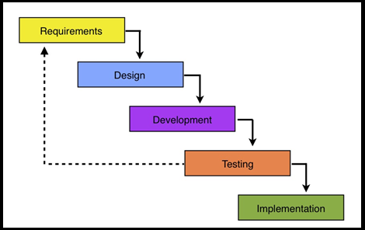

**Figure: 3.1**

**3.1.1 What is SDLC?**

SDLC is a process followed for a software project, within a software organization. It consists of a detailed plan describing how to develop, maintain, replace and alter or enhance specific software. The life cycle defines a methodology for improving the quality of software and the overall development process.

**STAGE 1: Planning and Requirement Analysis:-**

Requirement analysis is the most important and fundamental stage in SDLC. It is performed by the senior members of the team with inputs from the customer, the sales department, market surveys and domain experts in the industry.

**STAGE 2: Defining Requirements:-**

Once the requirement analysis is done the next step is to clearly define and document the product requirements and get them approved from the Customer or the market analysts. This is done through ‘SRS’ –Software Requirement Specification document which consists of all the product requirements to be designed and

Developed during the project life cycle.

**Stage 3: Designing the product architecture**:-

SRS is the reference for product architects to come out with the best architecture for the product to be developed. Based on the requirements specified in SRS, usually more than one design approach for the product architecture is proposed and documented in a DDS -Design Document Specification.

**Stage 4: Building or Developing the Product:-**

In this stage of SDLC the actual development starts and the product is built. The programming code is generated as per DDS during this stage. If the design is performed in a detailed and organized manner, code generation can be accomplished without much

**Stage 5: Testing the Product:-**

This stage is usually a subset of all the stages as in the modern SDLC models, the testing activities are mostly involved in all the stages of SDLC. However this stage refers to the testing only stage of the product where products defects are reported, tracked, fixed and retested, until the product reaches the quality standards defined in the SRS.

**Stage 6: Deployment in the Market and Maintenance:-**

Once the product is tested and ready to be deployed it is released formally in the appropriate market. Sometime product deployment happens in stages as per the organizations’ business strategy.

**3.2 About Java Script:**

* JavaScript is also known as a scripting language.
* A scripting language is a light weight encoding language.
* JavaScript is a typically surrounded straight into HTML pages.
* Everybody can used JavaScript without acquire a permit.

**3.3 Validations:-**

Verify whether a row a pleased a assured standard e.g. if a feature was not void or values was in individual series. Validations were also word of warning. A flag was position for row that despoiled validation but additional processing could be completed or mistake. A row despoiled validation and couldn’t be progression supplementary. Validations didn’t

Modify any problem data they just set the suitable flag. Both advice and mistake were logged in a split table for additional exam if needed.

**3.4 System Analyses:-**

Planning is an important activity in software project management. When a **software project** is planned, estimates of required human effort, chronological project duration and cost must be derived. Effective management of a software project depends on thoroughly planning the progress of the project.

The project schedule is given in the form of the Gantt chart given with the document:

|  |  |  |
| --- | --- | --- |
| **S. No** | **Activity** | **Time Duration** |
| 1 | Problem Definition | 4 days |
| 2 | Analysis | 2 days |
| 3 | Design | 4 days |
| 4 | Coding | 9 days |
| 5 | Testing | 3 days |
| 6 | Reporting & Documentation | 2 days |

**Table: 3.1**

**3.5Gantt chart:-**

|  |  |  |  |  |  |  |
| --- | --- | --- | --- | --- | --- | --- |
| **Problem Definition** |  |  |  |  |  |  |
| **Analysis** |  |  |  |  |  |  |
| **Design** |  |  |  |  |  |  |
| **Coding** |  |  |  |  |  |  |
| **Testing** |  |  |  |  |  |  |
| **Reporting &Documentation** |  |  |  |  |  |  |

**Table: 3.2**

**3.6 ER-Diagram:-**

An entity relationship diagram, also called entity relationship model, it is a graphical representation of entities and their relationships to each other, typically used in computing in regard to an organization of data within databases or information systems. An entity relationship diagram is a specialized graphic that illustrate the relationships between entities in a database, it also known as: ER Diagram.

ER model is a data model technique used in software engineering to produce the conceptual data model for an information system, Diagrams created using this ER model technique so we can say that Entity Relationship Diagrams illustrate the logical structure of databases it is one of the most cited papers of the computer software field. Currently the ER Model serves as the foundation of many system analyses. Mainly the rectangles are used to represent entities and the diamonds are used to represent the relationship.

Mainly three basic elements in ER-Diagrams:-

Entities are the “things” for which we want to store information. An entity is a person, place, thing or event. Attributes are the data we want to collect for an entity. Relationships describe the relations between the entities. ER-Diagram show entities in a database and relationships between tables within that database The Diagram help focus on how the database actually works.

**3.6.1 ER-Diagram Symbols & Notations:-**

**[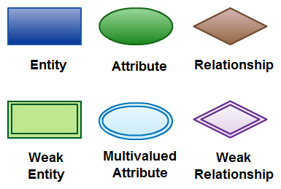](http://static3.creately.com/blog/wp-content/uploads/2012/03/ER-Diagram-Elements.jpeg)**

**Figure 3.2 Elements in ER diagrams**

**3.6.2 E-R diagram for blood bank management system:**

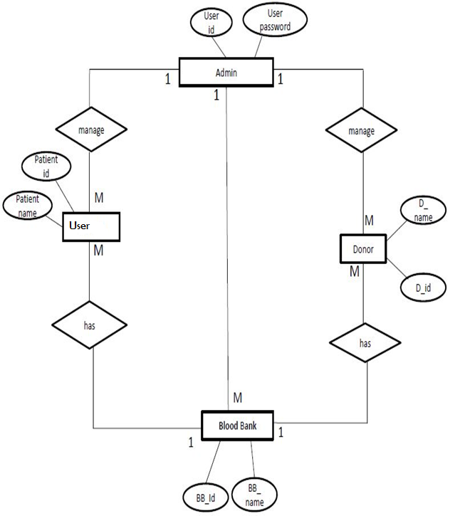

**Figure: 3.3**

In the above diagram, there is 1 to many relationships b/w Admin and User. The admin has its own attributes- id and password. Whereas Users has many Blood bank leading to many to one Relationship It has its own id and name.

And the admin has one more relationship b/w Donor i.e. one to many Donor having its own attributes- D name, D id, Donor can also relationship with blood bank i.e. many to 1 and Blood bank having its own attributes are BB id & BB name

Another Relationship b/w Admin and Blood Bank is 1 to many.

* 1. **Flow Chart:-**

A **Flowchar**t is a type of diagram that represents an algorithm, workflow or process, showing the steps as boxes of various kinds, and their order by connecting them with arrows. This diagrammatic representation illustrates a solution model to a given problem. Flowcharts are used in analyzing, designing, documentation or managing a process or program in various fields.

* + 1. 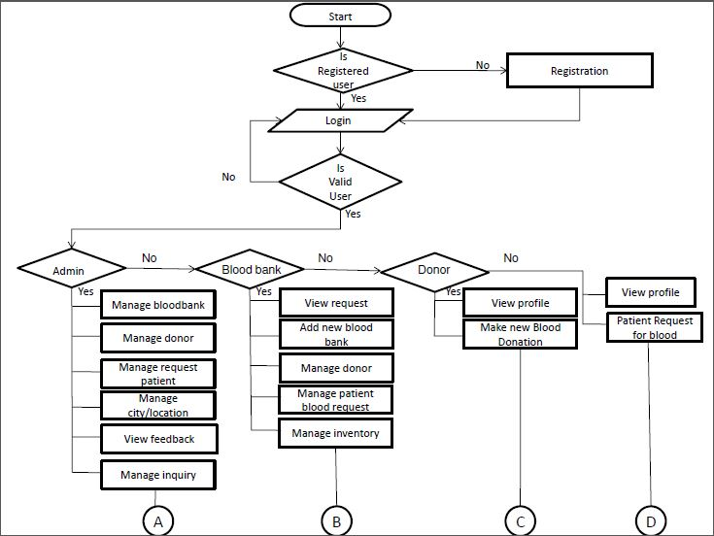**Project Flow Chart:-**

**Figure: 3.4**

**3.8 DESIGNING OF USE CASE:-**

Identify the users of the system for each category of users, create a user profile. This includes all roles played by the users relevant to the system.

Identify significant goals associated with each role to support the system. The system’s value proposition identifies the significant role.

Create use cases for every goal associated with a use case template and maintain the same abstraction level throughout the use case. Higher level use case steps are treated as goals for the lower level.

**3.8.1 Use Case Diagram of Admin:-**

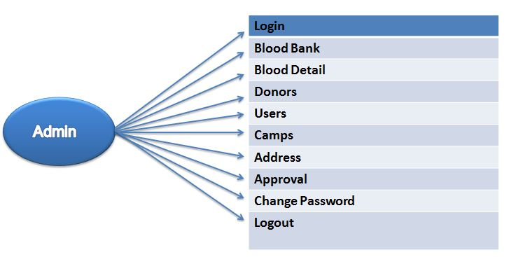

**Figure: 3.5**

This diagram show that what tasks will admin can perform in our project admin can Login, add Blood banks, add Blood details, add donors, add Camps ,change password and provide username and password to student and Users, add addresses and also accept/reject Approval all record. Also change his password, and then logout

**3.8.2 Use Case Diagram of Donor:-**

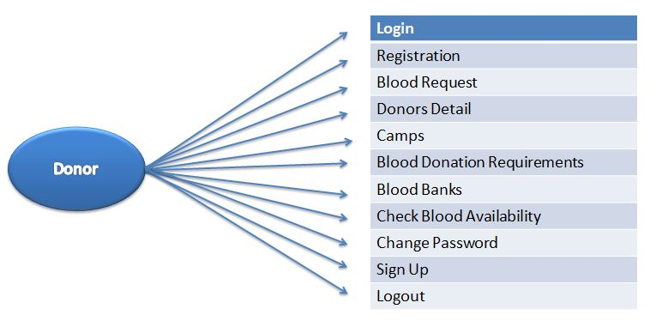

**Figure: 3.6**

This diagram show that what tasks will donor can perform in our project Donor can registered, check another Donor details ,Check Camps ,Check Blood Availability and Also change his password

**3.8.3 Use Case Diagram of User:-**

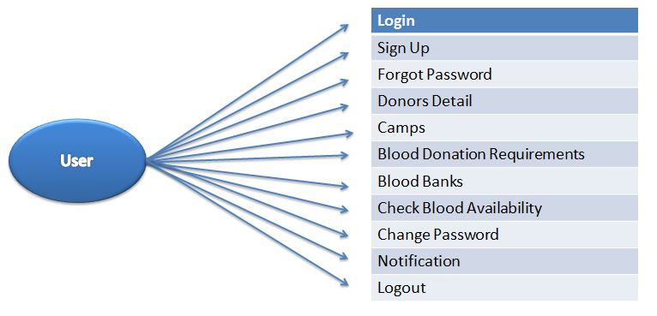

**Figure: 3.7**

Figure 3.6 show that what tasks will User can perform in our project user can check camps, blood requirement, blood availability, check notification and Also change his password

**3.9 Activity Diagram:-**

Activity diagrams are graphical Representations of [workflows](https://en.wikipedia.org/wiki/Workflow) of stepwise activities and actions with support for choice, iteration and concurrency. In the [Unified Modelling Language](https://en.wikipedia.org/wiki/Unified_Modeling_Language), activity diagrams are intended to model both computational and organizational processes

Activity diagrams are constructed from a limited number of shapes, connected with arrows. The most important shape types:

* Rounded rectangles represent actions;
* Diamonds represent decisions;
* Bars represent the start (split) or end (join) of concurrent activities;
* A black circle represents the start (initial state) of the workflow;
* An encircled black circle represents the end (final state).

**3.9.1 ACTIVITY DIAGRAM OF ADMIN:-**

In this first admin Log-in through his username and password if the username and password invalid so error message will be generate But if the username and password is valid admin will going to home page then he perform his tasks like:-

* Admin can manages all the blood bank
* Admin can manage donors
* Admin can manage patient request
* Admin can add camps details
* Admin can add city, location
* Admin can view feedbacks
* Admin can change his password
* Admin also can manage query
* Admin can logout

**ACTIVITY DIAGRAM OF ADMIN** 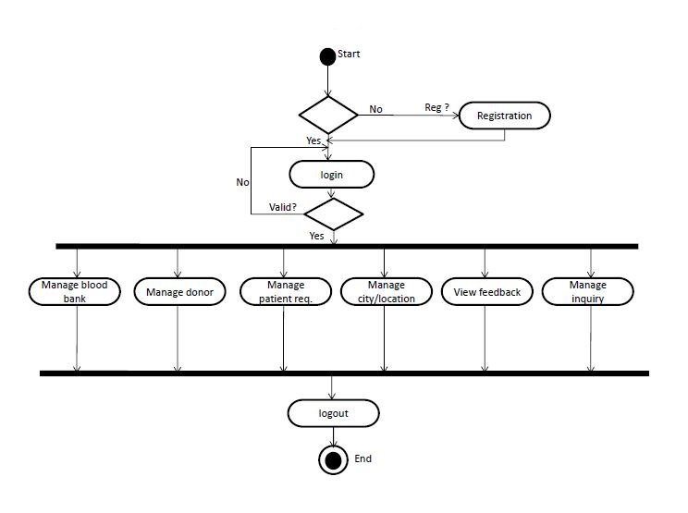

**Figure: 3.8**

**3.9.2 ACTIVITY DIAGRAM OF USER:-**

In this first user Log-in through his username and password if the username and password invalid so error message will be generate, but if the username and password is correct user will going to home page then he perform his tasks.

* User can view all details of Blood banks
* User can view his profile
* User can change his password
* User can make new blood donation
* User can Logout

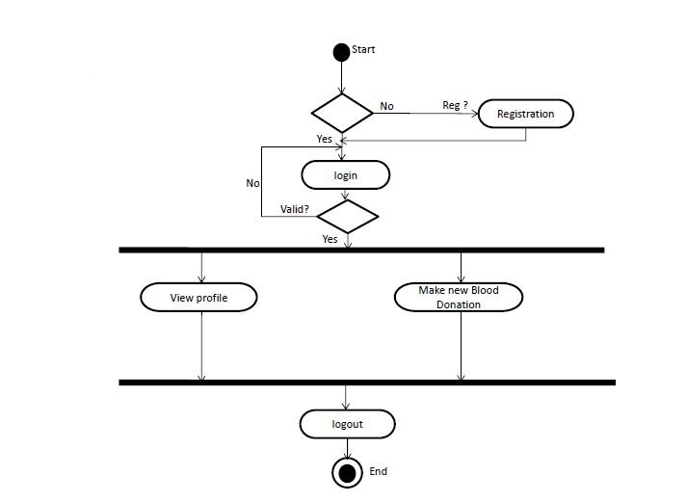

**Figure: 3.9**

**3.9.3 ACTIVITY DIAGRAM OF DONOR:-**

In this first Donor Log-in through his username and password if the username and password invalid so error message will be generate, but if the username and password is correct donor will going to home page then he can do following tasks:-

* View his profile
* View request of blood etc
* Donor can logout

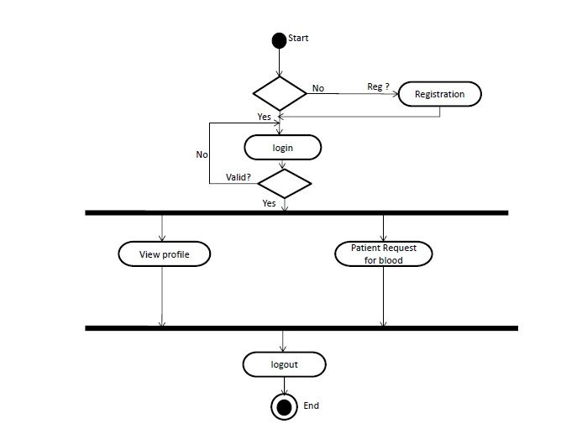

**Figure: 3.10**

**3.10 Data Dictionary:-**

A data dictionary, or metadata repository, as defined in the IBM dictionary of computing, is a “centralized repository of information about data such as meaning, relationships to other data, origin, usage, and format.”

**3.10.1 Sign Up Table:-**

This table is store user registration information. All the new users first fill the registration form. Then user will login to our website using username and password.

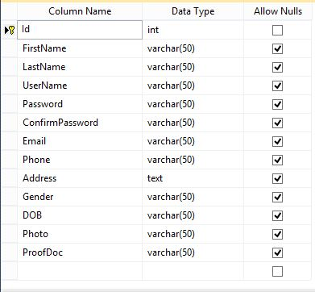

**Table: 3.3**

**3.10.2 Camp Detail Table:-**

This table is store camp details. Admin can add camps in admin panel. Where camp is located. And all the user and donors can see all the detail of the camp.

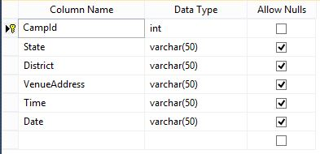

**Table: 3.4**

**3.10.3 Blood Request Table:-**

This table stores donor’s blood request details. Donor can fill the form to our website and send the request.

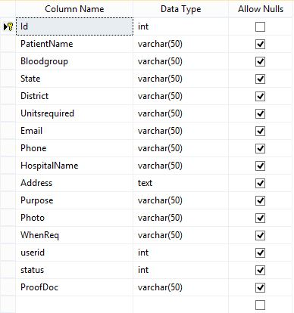

**Table: 3.5**

**3.10.4 Blood Group Table:-**

This table stores blood group category like A+, B+,A-,B-,O+,O-,AB+,AB-. This blood group is selected by the users and donors for his/her blood group for filling the registration, blood request, and blood donation form.

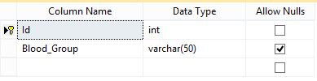

**Table: 3.6**

**3.10.5 Blood Donor Registration Table:-**

This table stores Blood donor registration detail. Donor can fill the blood donor registration form for using this information is shown in the table.

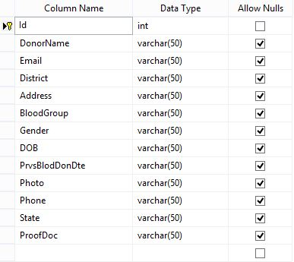

**Table: 3.7**

**3.10.6 Blood Bank Table:-**

This table stores detail about the blood banks. This information is filling by the admin and it can see by the users and donors in our blood bank website

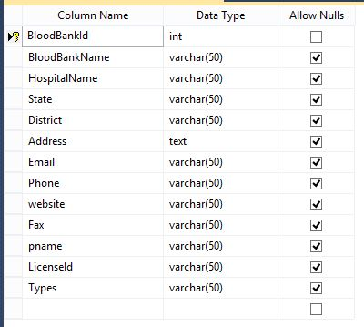

**Table: 3.8**

**3.10.7 Admin Login Table:-**

This table stores the admin username and password of login to admin panel. And make changes in our website

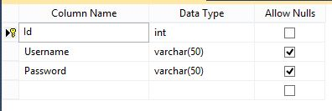

**Table: 3.9**

**3.10.8 State and City Table:-**

This table stores state and district names for selecting user’s and donor’s location.

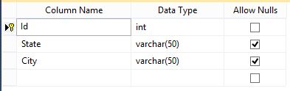

**Table: 3.10**

**CHAPTER 4**

**SYSTEM DESIGN SNAPSHOTS**

**4.1 Index Page:-**

This is index page of our web application and it is first page of our website”**24x7Blood Bank**”. In this page camps photographs are shown using the slider

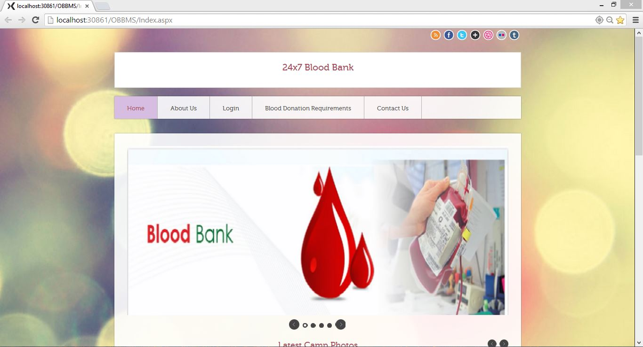

**Figure: 4.1**

In our web application we are added a Google map for showing user’s current location and admin can detect the location of the user for which place our website is running.

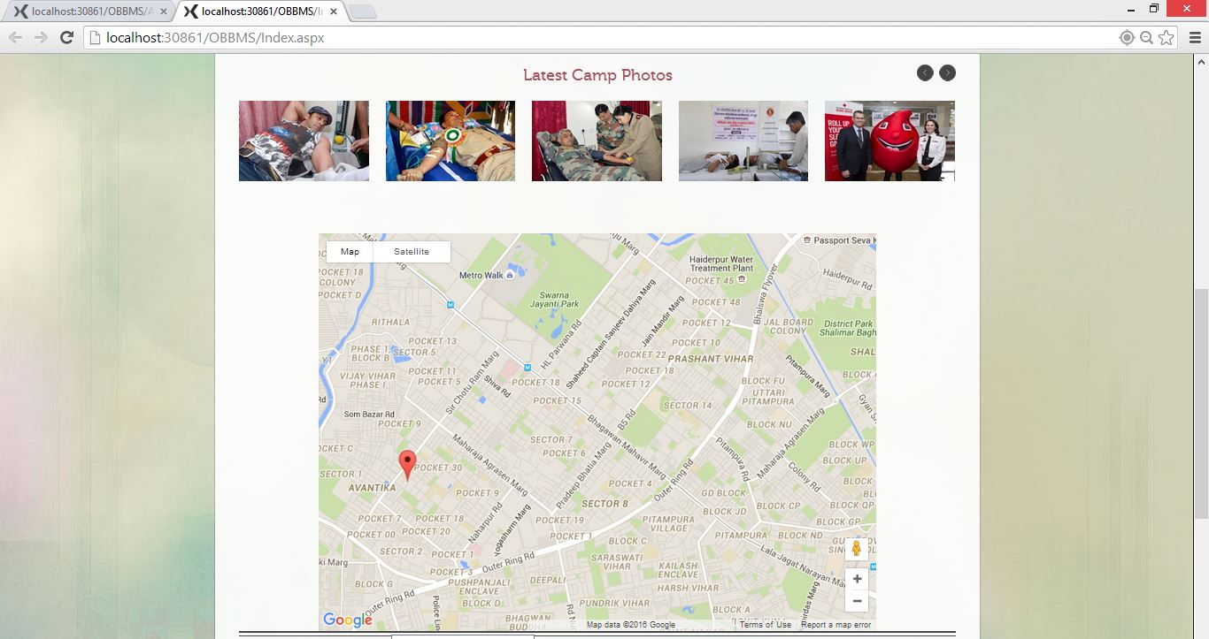

**Figure: 4.2**

**4.2 About Us Page:-**

This is About Us page of our web application. This page shows the information about

Our Website.

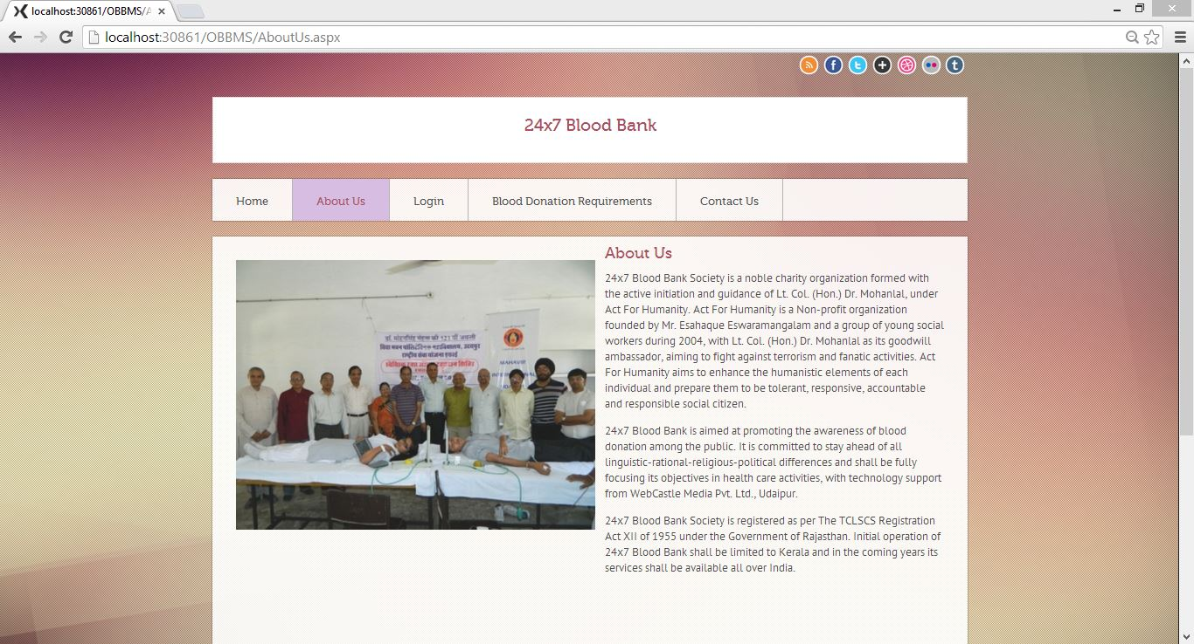

**Figure: 4.3**

**4.3 Blood Donation Requirements Page:-**

This is very important page for donating blood. In this page all the terms and conditions

Are shown for donation the blood and it is must require without this requirement anyone

Can’t donate blood.

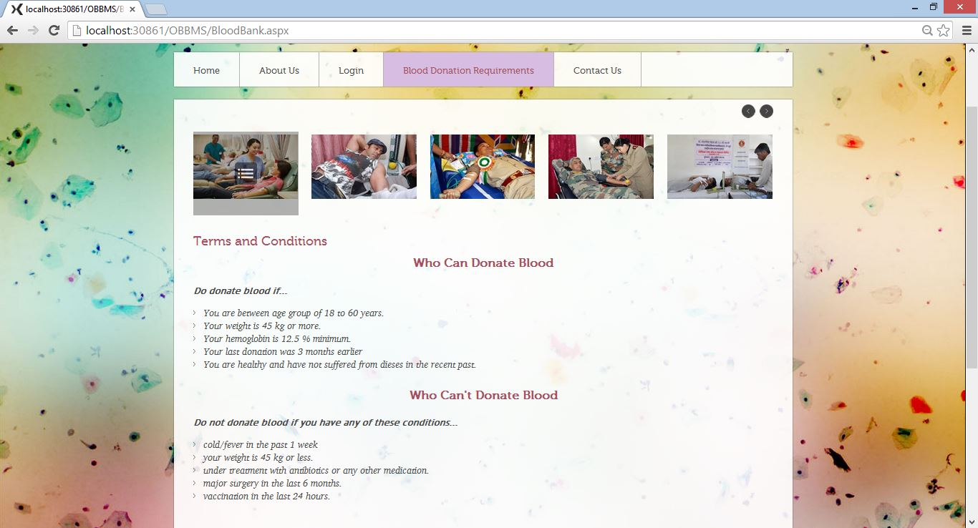

**Figure: 4.4**

**4.4 Contact Us Page:-**

This is contact page of our web application. In this contact information is available for users who need a blood.

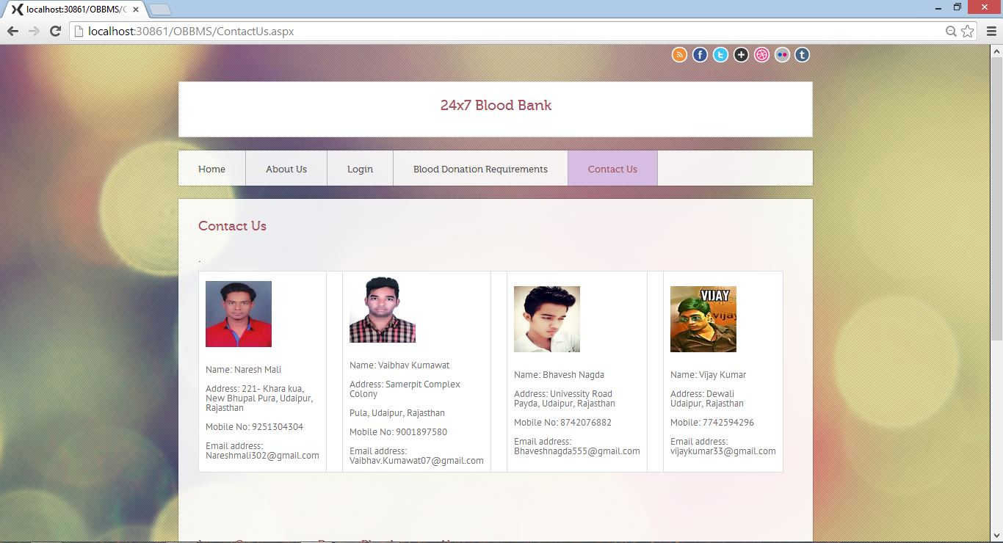

**Figure: 4.5**

**4.5 Sign Up Page:-**

This is the registration page of our web application. In this user can register itself with the help of filling the registration form by the users.

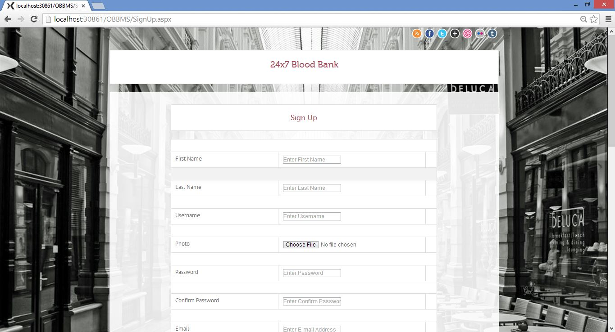

**Figure: 4.6**

**4.6 Forgot Password Page:-**

This page is specially prepared for users who are registered in the application. This provides way to login in the web application for user who has forgotten his or her password. User can enter his/her Email address and press submit button and then password is come in the user mobile number.

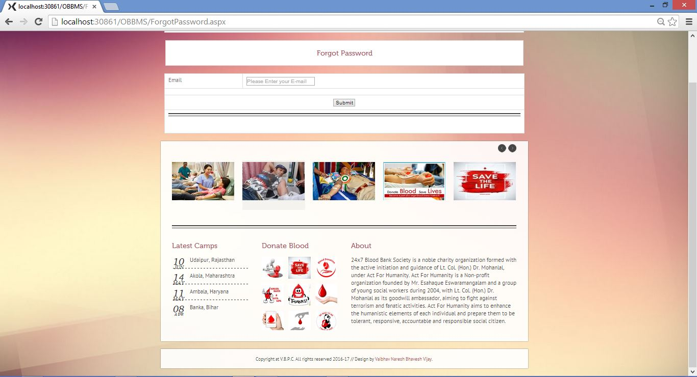

**Figure: 4.7**

**4.7 Login Page:-**

This is the login page of our web application. In this page user can login with their username and password.

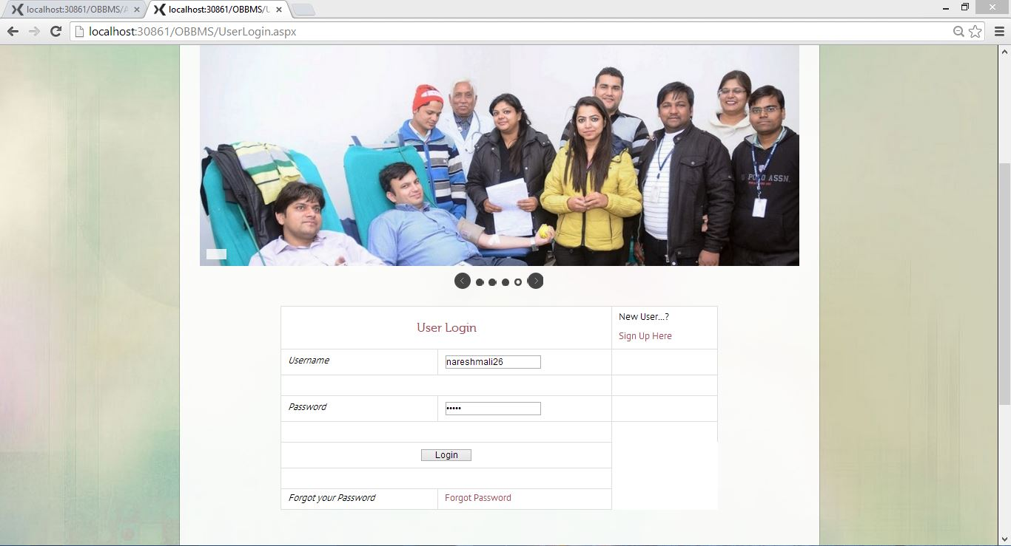

**Figure: 4.8**

**4.8 Home Page:-**

This is the home page of our website. In this page camps photographs are shown using the slider

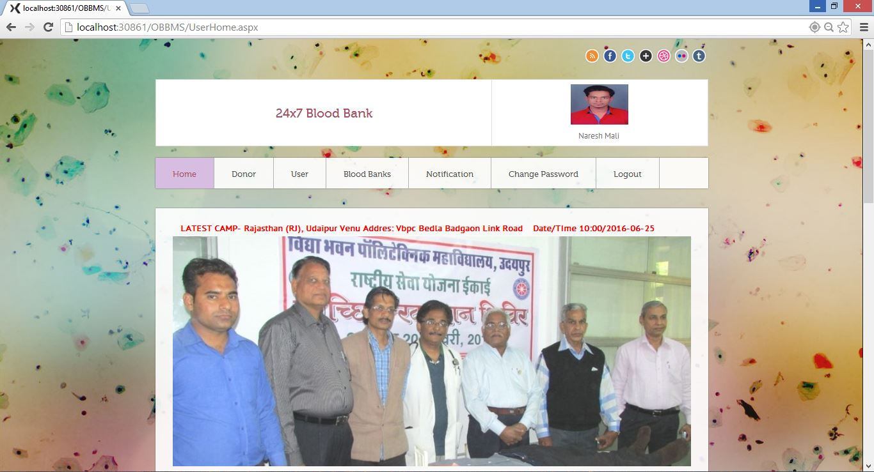

**Figure: 4.9**

In our web application we are added a Google map for showing user’s current location and admin can detect the location of the user for which place our website is running.

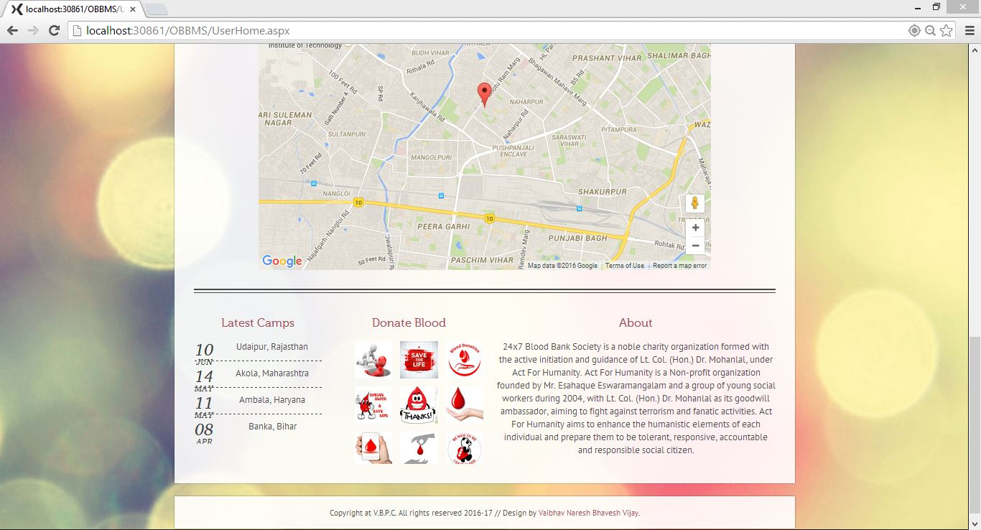

**Figure: 4.10**

**4.9 Donor Registration Page:-**

This is the blood donor registration page of our web application. In this user can register itself with the help of filling the registration form by the donors.

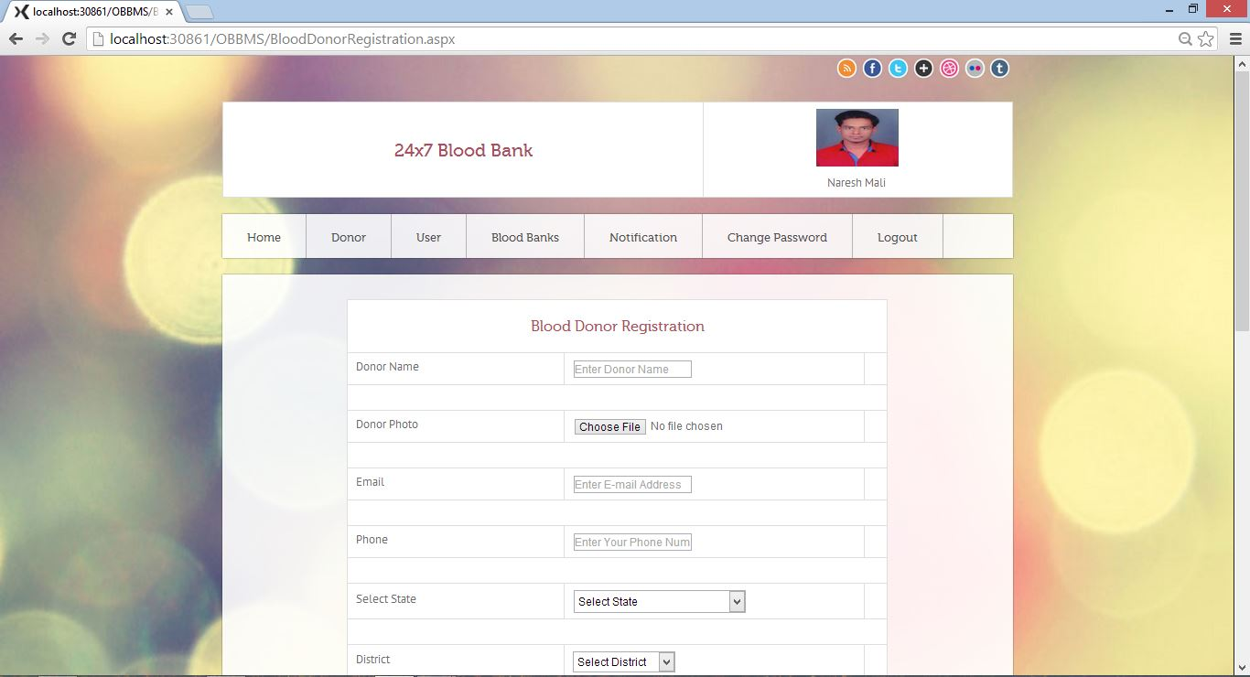

**Figure: 4.11**

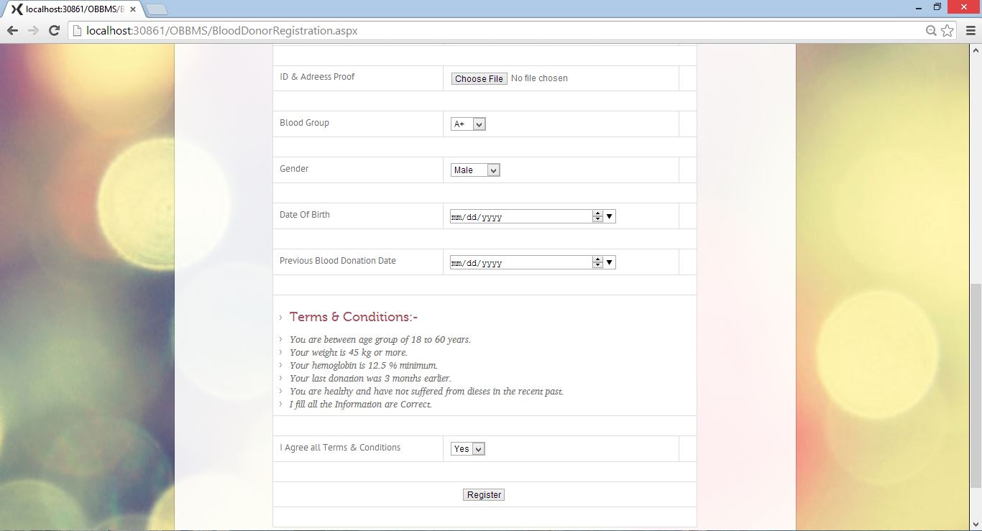

**Figure: 4.12**

**4.10 Blood Request Page:-**

This is the blood request page of our web application. In this donors can request itself with the help of filling the blood request form by the donors.

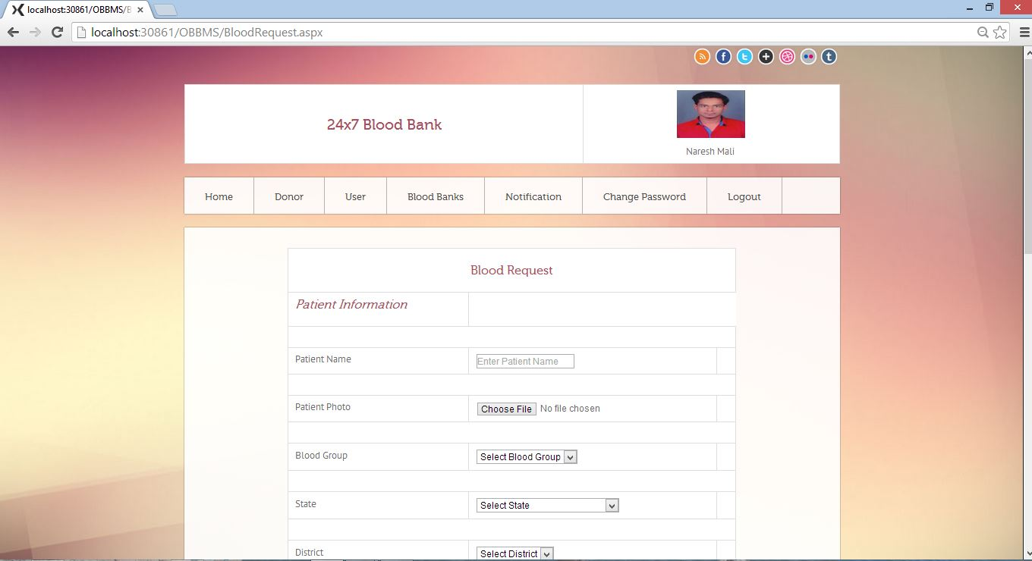

**Figure: 4.13**

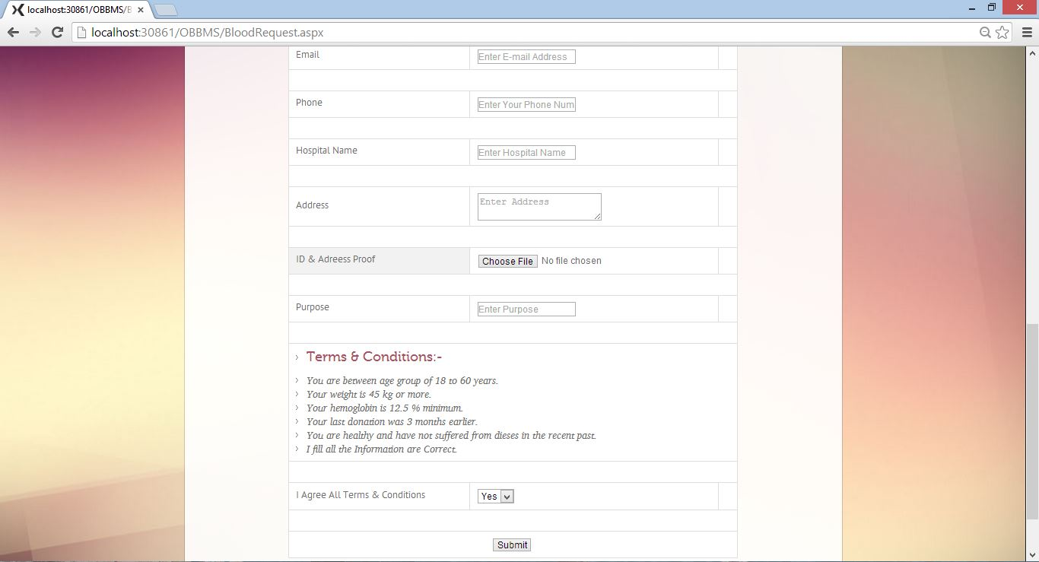

**Figure: 4.14**

**4.11 Find Donors Page:-**

This is the donor page of our web application. In this page donor can find donor who can donate blood they search location using state, district, blood group. And check the donor details.

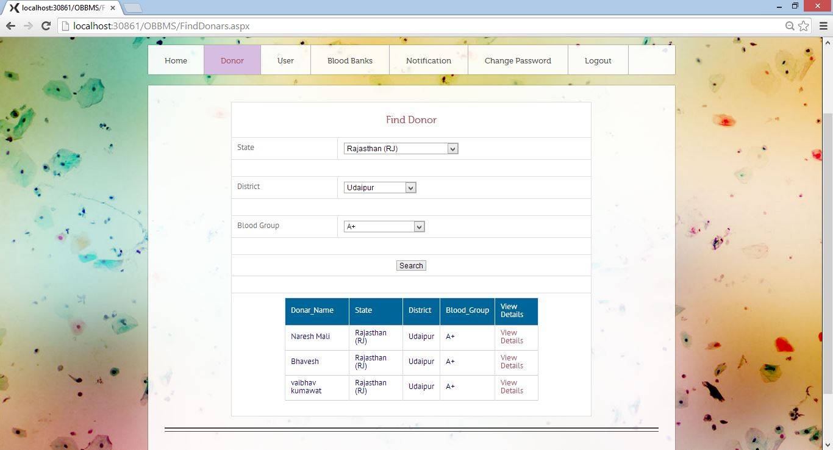

**Figure: 4.15**

**4.12 Donor Detail Page:-**

This is the donor detail page of our web application. In this page donor can find the donors and check information of another donor.

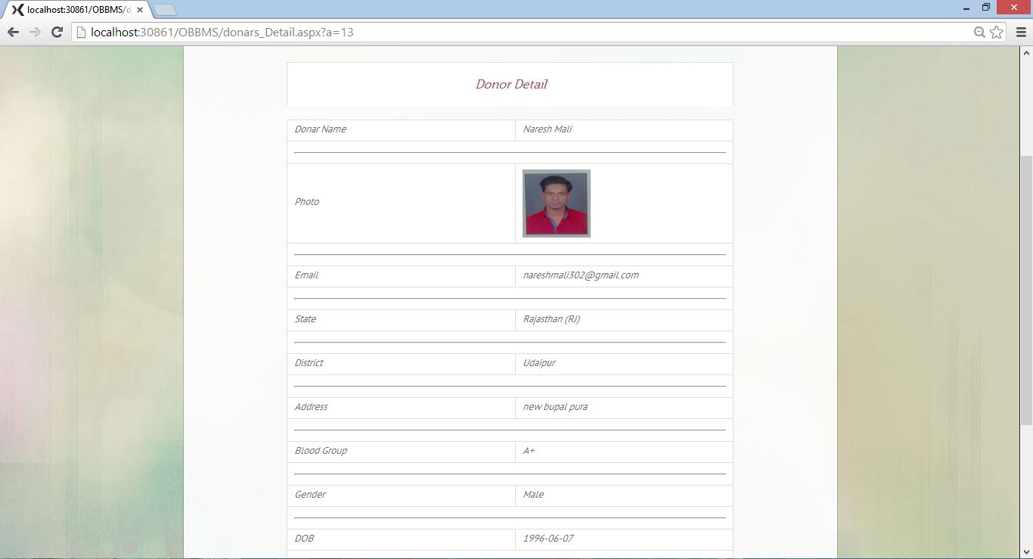

**Figure: 4.16**

**4.13 Camps Page:-**

This is the camp page of our web application. In this page donor can check the camp details and come to donate blood

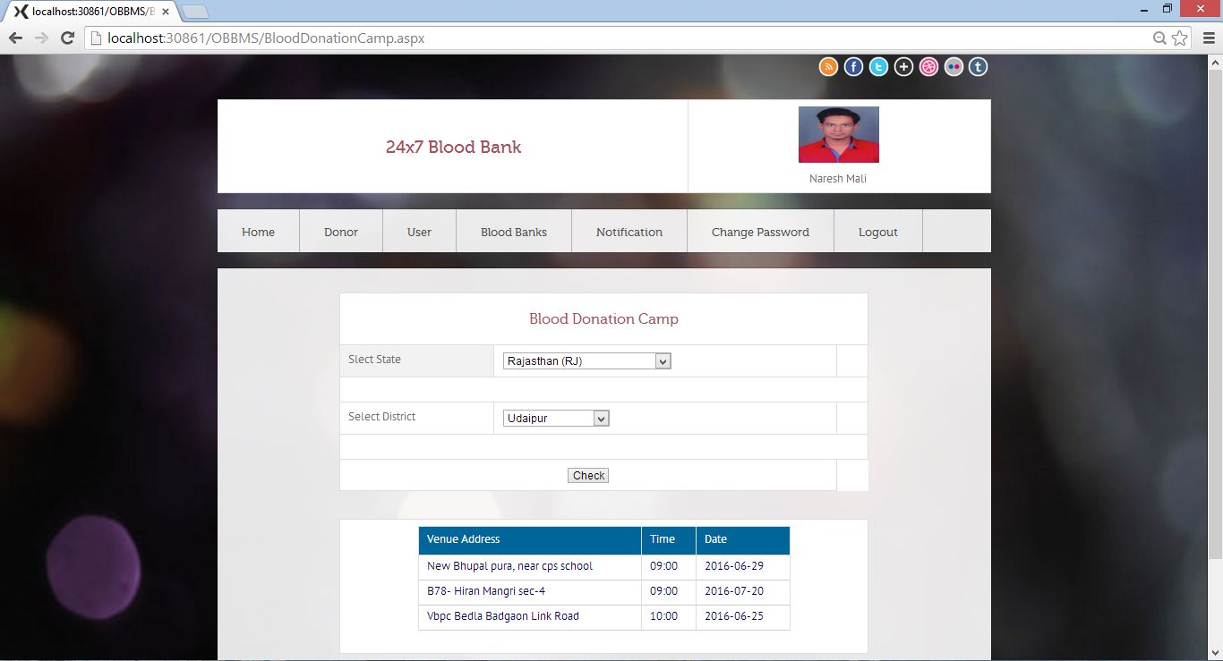

**Figure: 4.17**

**4.14 Blood Bank Page:-**

This is Blood Bank page of our web application. In this page Donors can find the nearest blood bank or all the blood bank using state and district and check the information about the blood bank

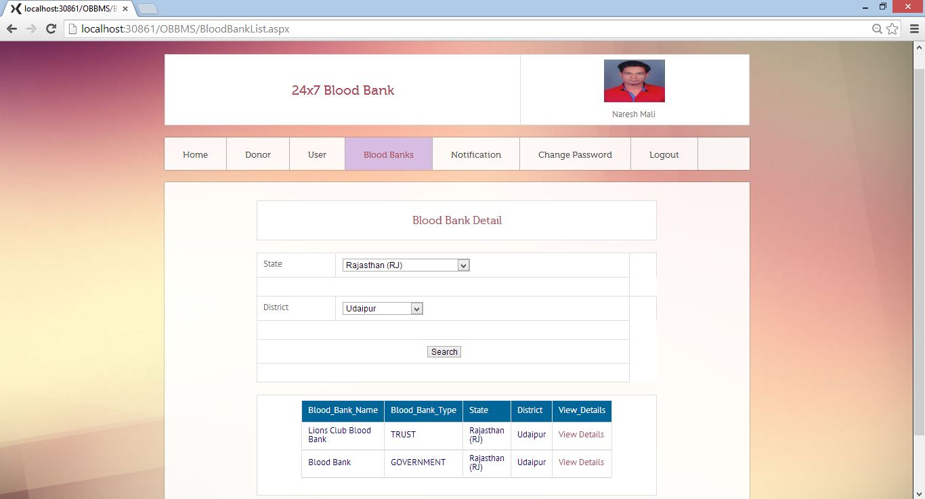

**Figure: 4.18**

**4.15 Blood Bank Detail Page:-**

This is Blood bank detail page of our web application. In this page donors can check the blood bank details.

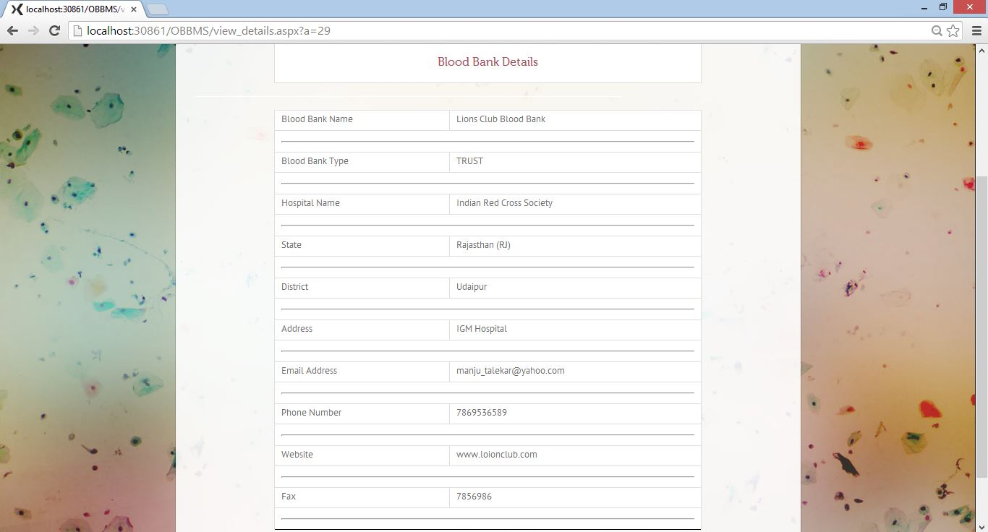

**Figure: 4.19**

**4.16 Check Blood Availability Page:-**

This is blood availability page of our web application. In this page donors can check the blood detail in the district in the form using drop down list of state and district and blood group.

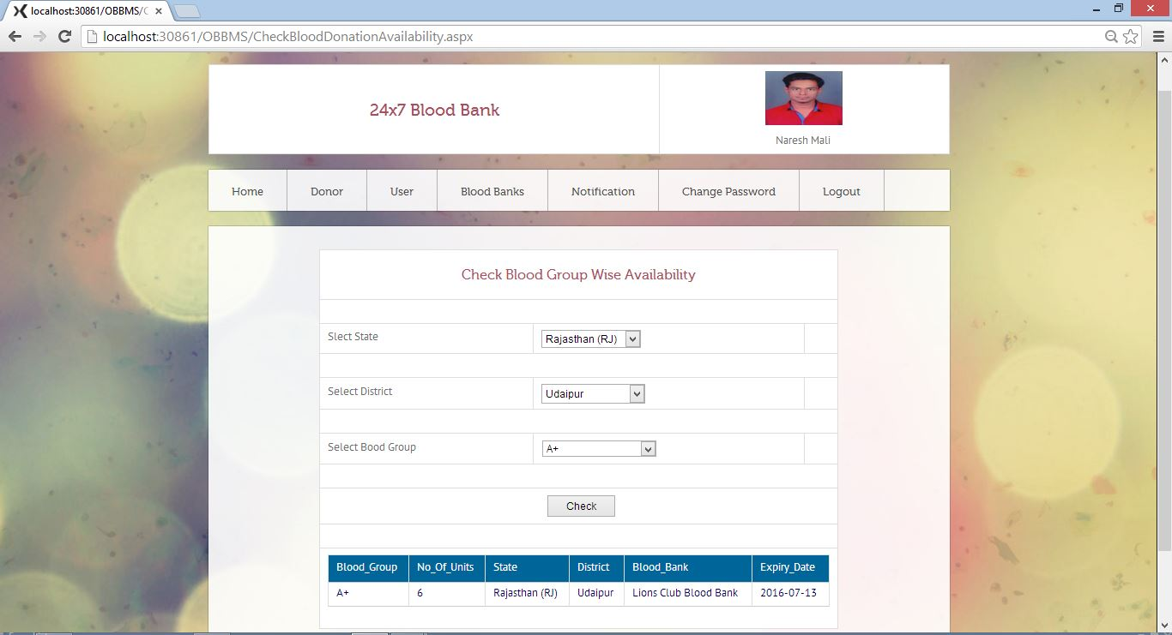

**Figure: 4.20**

**4.17 Notifications Page:**

This is Notification page of our web application. In this page Donors can show the blood request detail for approving his/her blood request. When admin can check all the details and approve the request then notification comes to donors in this page

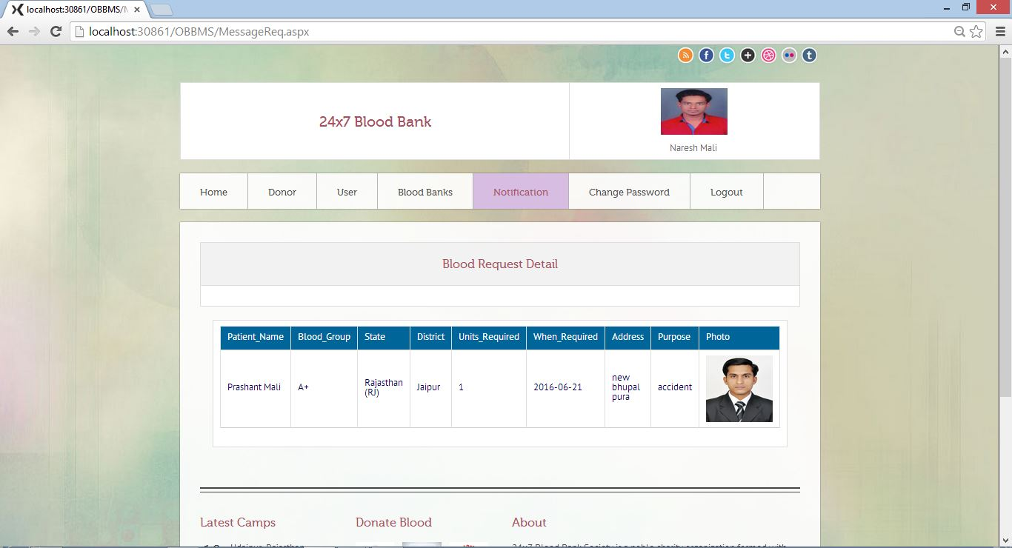

**Figure: 4.21**

**4.18 Change Password Page:-**

This page is specially prepared for users who are registered in the application. This provides way to login in the web application for user who has changed his or her password. User can enter his/her old password and new password then press submits button and then password changed.

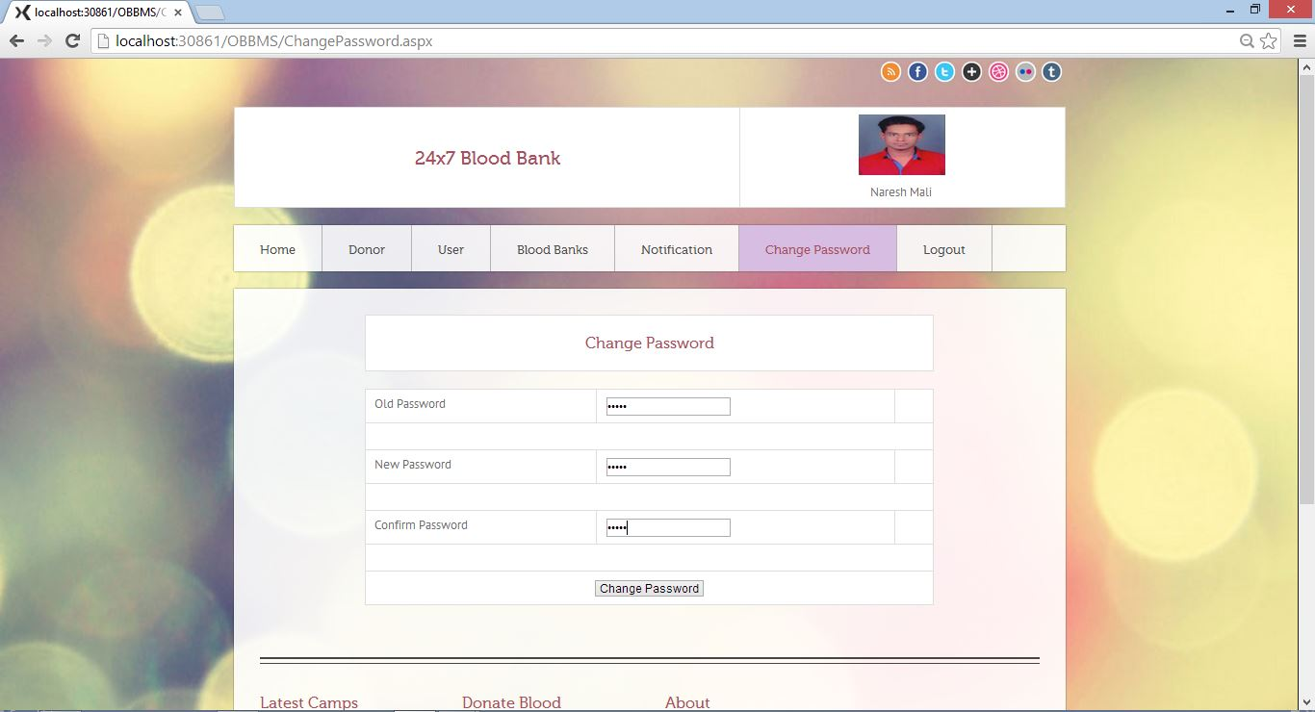

**Figure: 4.22**

**4.19 Admin Index Page:-**

This is the admin index page of our web application and it is first page of our admin panel”**24x7Blood Bank**”. In this page camps photographs are shown using the slider.

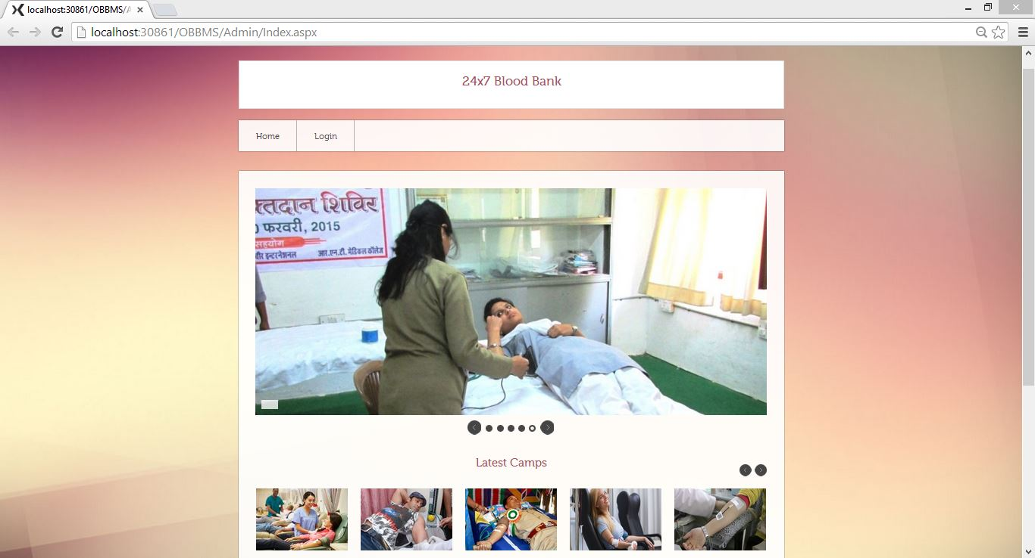

**Figure: 4.23**

**4.20 Admin Login Page:-**

This is the Admin login page of our web application. In this page admin can login with their username and password.

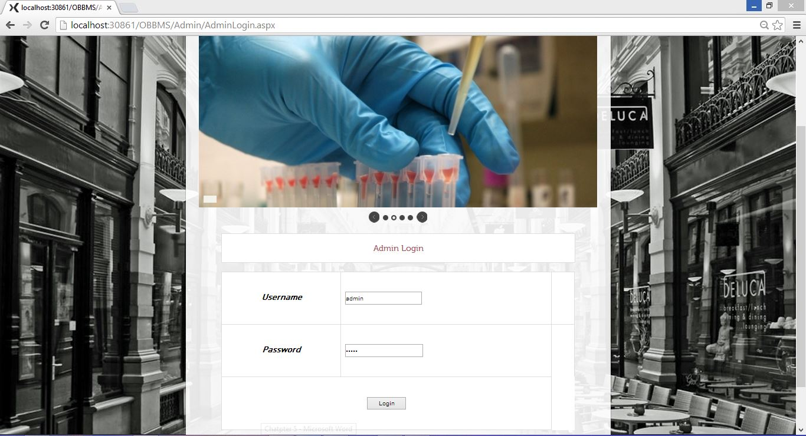

**Figure: 4.24**

**4.21 Admin Home Page:-**

This is admin panel or home page of our web application. In this page admin can choose menu option for add something or remove.

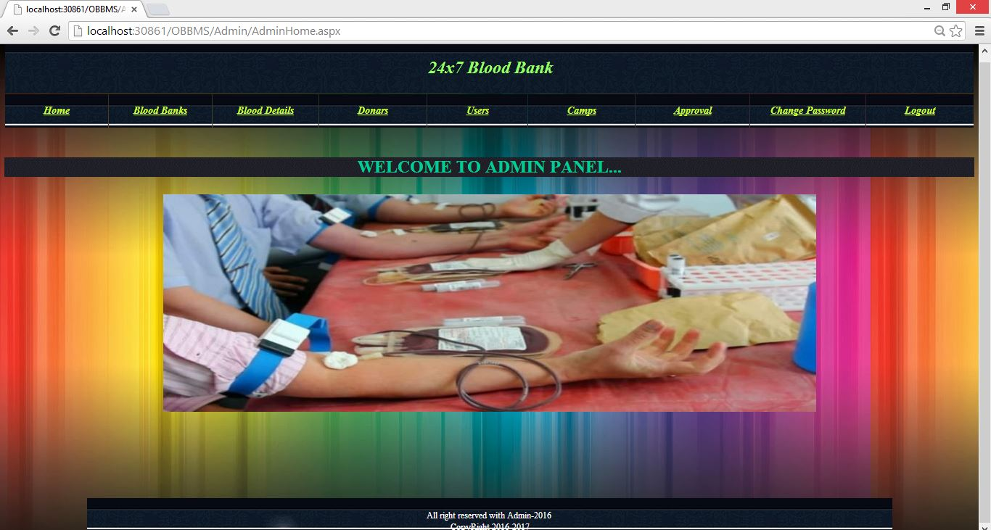

**Figure: 4.25**

**4.22 Blood Banks Page:-**

This is blood banks page of our admin panel in our web application. In this page admin can add blood banks details.

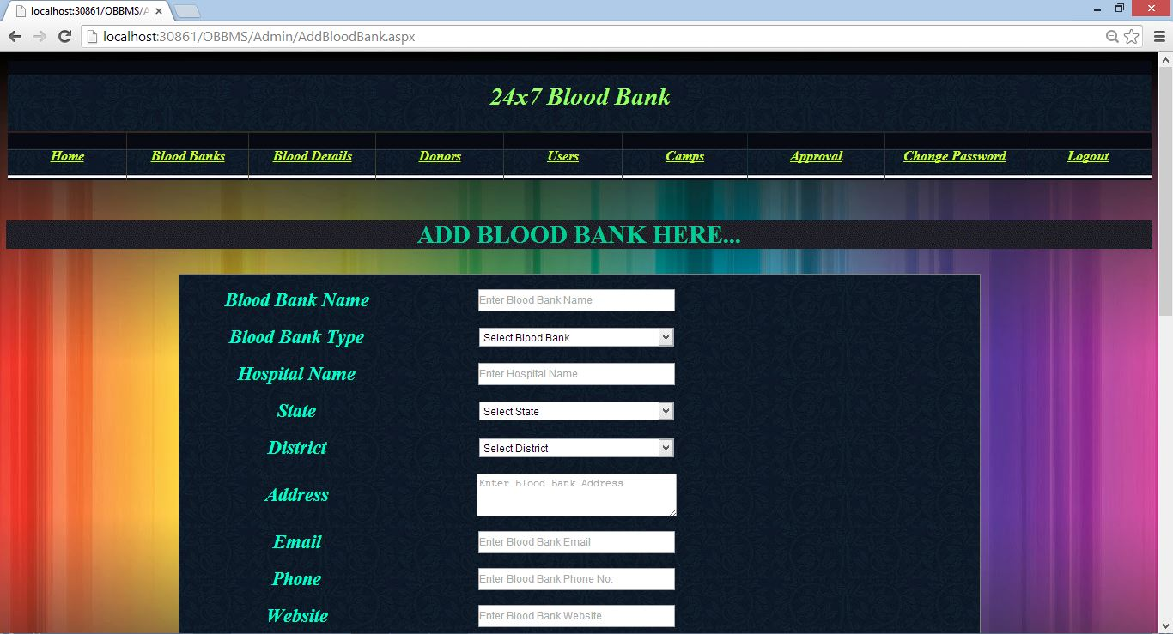

**Figure: 4.26**

**4.23 Blood Banks Detail Page:-**

It is Blood Banks Page from the above. In this page blood bank details are shown in

Grid view.

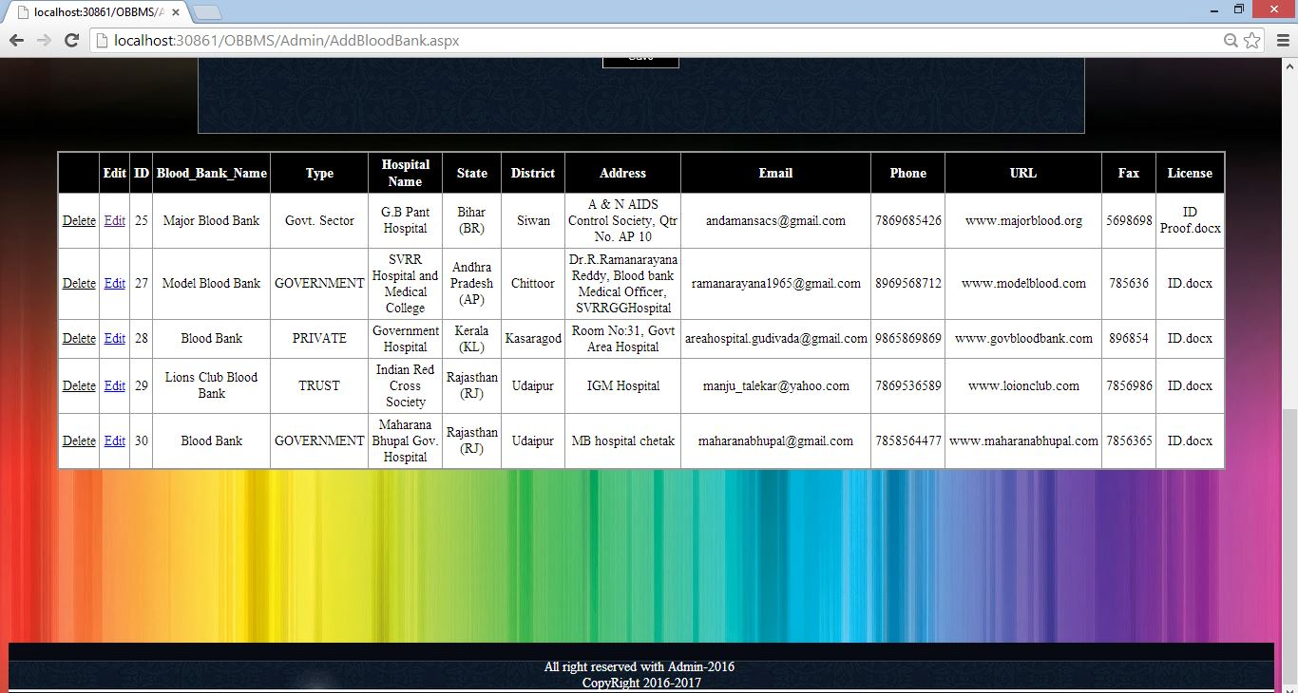

**Figure: 4.27**

**4.24 Blood Detail Page:-**

This is blood detail page in admin panel of our web application. In this page admin can add details about the blood.

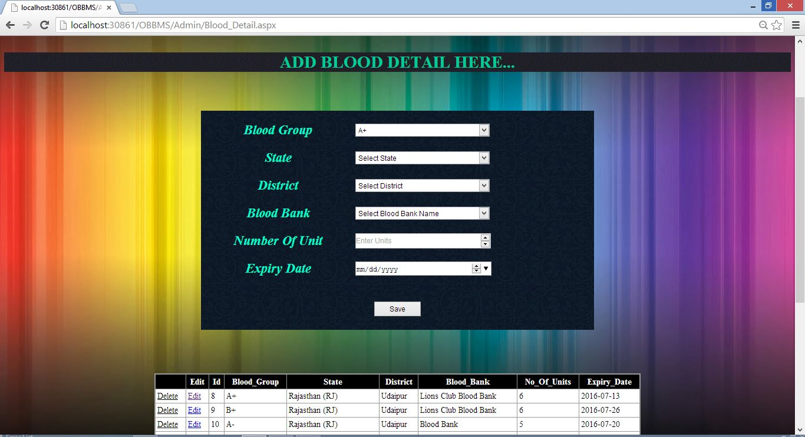

**Figure: 4.28**

**4.25 Donors Page:-**

This is donors detail page in admin panel of our web application. In this page admin can check all the information about the donors.

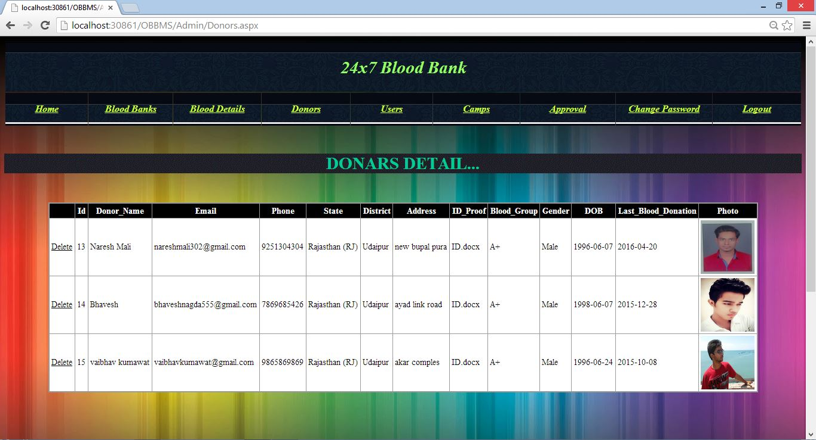

**Figure: 4.29**

**4.26 Users Page:-**

This is users detail page in admin panel of our web application. In this page admin can check all the information about the users.

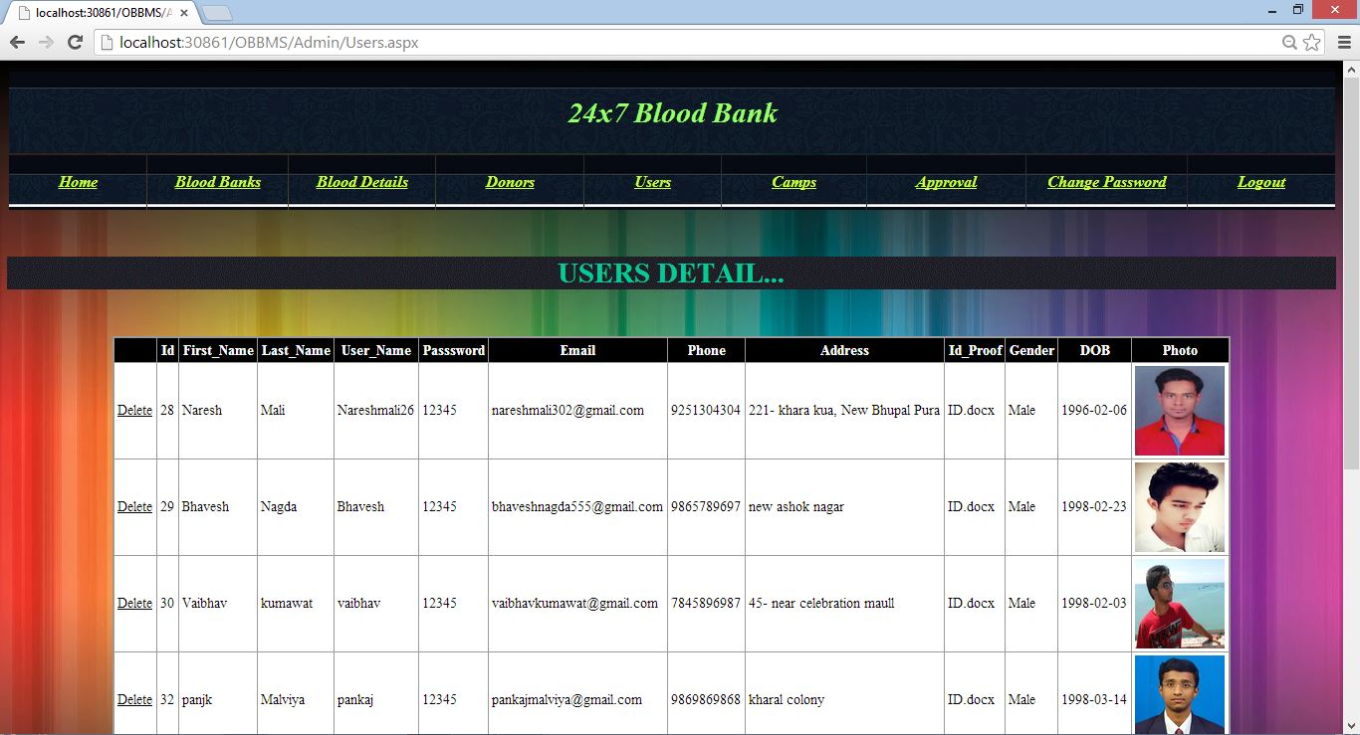

**Figure: 4.30**

**4.27 Camps Page:-**

This is camps page in admin pane of our web application. In this page admin can add details about the camps.

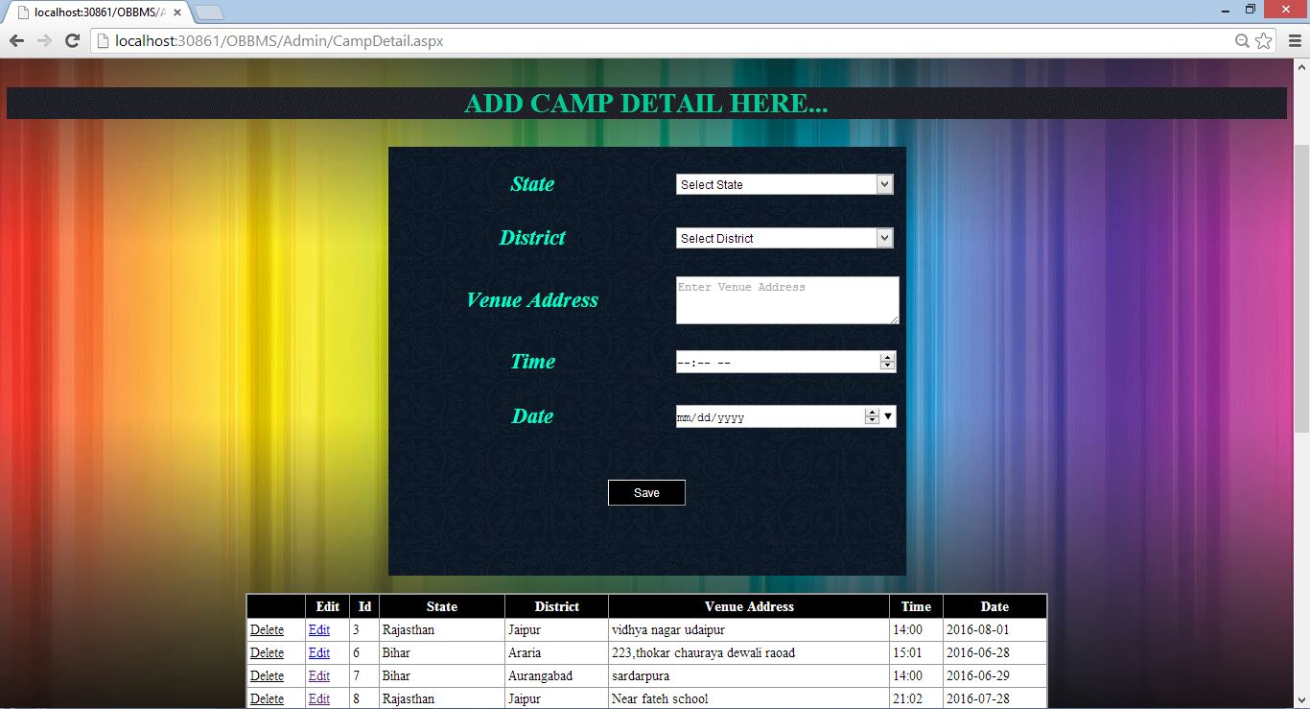

**Figure: 4.31**

**4.28 Approval Page:-**

This is approval page in admin panel in our web application. In this page admin can approve donor’s blood request.

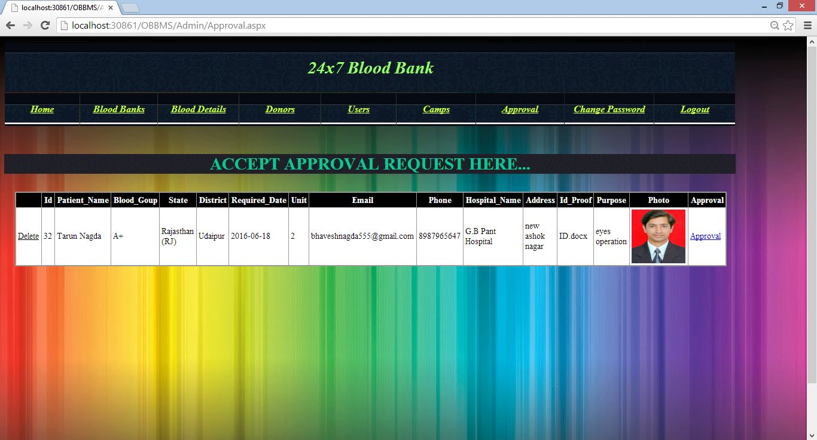

**Figure: 4.32**

**4.29 Change Password Page:-**

This is change password page in admin panel of our web application. In this page admin can change his/her password. First enter his/his current password and then enter new password and then press change password button to change his/her password

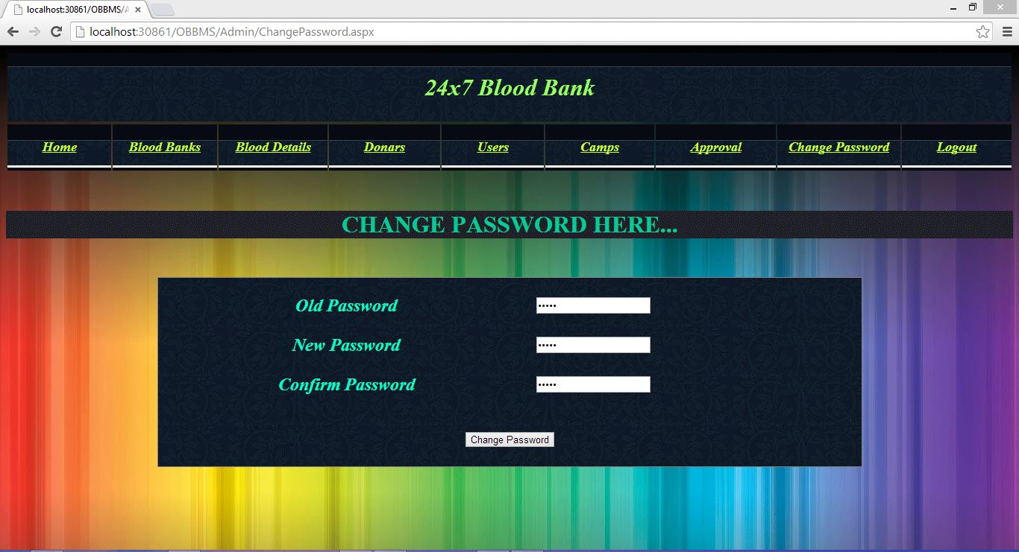

**Figure: 4.33**

**CHAPTER 5**

**RESULT &FUTURE ENHANCEMENT**

**Result:**

This website will help to provide finding rarely available blood groups. Sometimes we don’t get blood group in emergency, this will solve this problem. This will reduce the deaths which due to lack of blood during operations. We have made this website because when any emergency is there are we need a blood at the moment we do not get a blood easily so this website give us the detail of about various donors who used to donate their blood. The Blood Donation Agent is to create an e-Information about the donor and organization that are related to donating the blood. Through this application any person who is interested in donating the blood can register himself in the same way if any organization wants to register itself with this site that can also register. Moreover if any general consumer wants to make request blood online he can also take the help of this site.

**Future Enhancement:**

**System Development:**

In future we will add extra technique and ways to develop this website. We will also distinguish attractive designing effect.

So wherever it require we will use according to design. And we will also try to add new technology and newest idea. We will try our best to meet their expectation.

**Increase Security Level:**

In future we will increase the security level of our website. This time we have not given return code for security but in future will try to work on this option. This will be our main focus on our website.

**Video Conference:**

Add Video Conference to blood bank with directly donor/user

**Add Chatting Facility:**

User directly chats with donor who donates blood.

**SUMMARY & CONCLUSION**

As the working of 24 days has been provide to us. We completed our project in the fixed duration with our satisfaction even through period were not wide and detailed study of .net framework is not possible, but we have tried to collect the more information about .net framework, SQL server and Microsoft visual studio.

The working on the project “**24x7Blood Bank**” was an extremely learning experience. We came across no. of new concepts and also enhanced our technical knowledge. We were capable to overcome the position. We have used the ASP.NET in such a manner that this website is friendly with all the browsers like Internet explorer, Chrome, Firefox. Exact now this website is in the testing stage.

In this Project report, we have thanked to all the people who helped me in my project work. After that we had written some line about my company from where we have to complete our Project. Then we have described about our project that what we did in my website, what all we learnt etc. We added snapshot of all the website that we have created and designed in our website. We have also added snapshot of database table which we have used in our website

Although we have faced many crisis during the designing and the thoughtful part but remaining to the good support of our team and the direction given through our teachers.

**REFERENCES**

We are using various type of books and websites from which we get the Knowledge about ASP.NET. Which are following:-

1. Fundamentals of Software Engineering. New Delhi: Prentice-Hall India.

2. Software Engineering, Girdhari Singh, ShaliniPuri.

3. Fundamental of Software Engineering Rajib mall, Phi.

4. Essential of Dot Net Programming Theory and Application (Sanjib k Sahu).

6. WWW.Google.com.

7. WWW.W3schools.com.

8. Photoshop.

9. WWW.code Project.com